

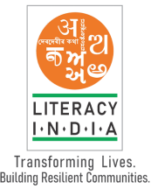

**Literacy India Community College (LICC)**

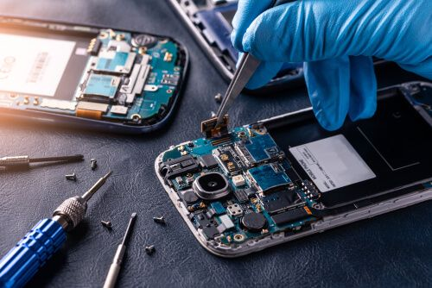**Programs Offered**

* Robotics/Tinkering
* Computer Hardware
* Mobile Repairing
* Cooking/Hospitality
* Beauty & Cutting
* Electrical Troubleshooting
* Two-wheeler Repairing
* Mobile Journalism
* Computer Science
* Call Centre/BPO
* Logistics
* Data Digitization
* z Natural Farming Market connect
* 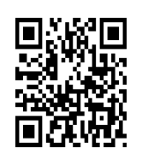Banking

Limited seats

Register Now

**www.literacyindia.org**

**Session starts From**

**January 2024**

**Contact No. 8588853380**